CIS/IM 452/552 – Assignment #8 – **Due Friday** **3/13 before 11:55pm**

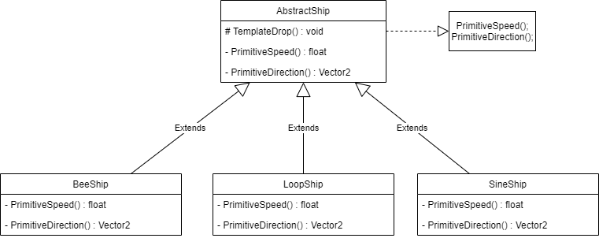Objective: Create a mini-game implementing the Template Method Design Pattern.

**Deliverable 3:** Include each of the following reflection questions and your answers to them in your single document you will submit on Sakai.

1. What is the multi-step process you are implementing with the Template Method design pattern?

The ships all have unique flight patterns.

1. How is the process different across the subclasses that implement parts of the template method differently?

The ships calculate their flight patterns in subclasses, but perform the translations in the base class.

1. What does the player do in the game that determines whether or not one of the hooks you are using will call the method it is controlling? In other words, what does the player do that triggers one of your hooks?

In my game, the player affects how certain ships fly by moving about in the world.

1. What were the benefits of using the Template Method Pattern to make your mini-game?

I was able to rapidly produce a large number of ships in a relatively short amount of time.

1. Did you find any drawbacks to using the Template Method Pattern? If so, what were they?

Honestly, I felt like the Template Method was useful. It was much easier to implement and honestly just felt like an application of polymorphism over anything.

1. What is the player’s goal in your mini-game and what makes it challenging?

The player’s goal is to destroy all of the enemy ships without getting hit. It’s difficult because the enemy ships have erratic flight paths.

1. How does the game communicate its goal(s) to the player?

The player has a counter on the screen that shows the required number of ships.

1. How can the player fail at the game and how does the game detect it?

The player fails if they are hit before they destroy all the enemy ships.

1. How does the game give players feedback about how well they are doing?

The player’s progress is measured and displayed on screen.